Old Business:

Motion to Accept Minutes from August Meeting

Bring Meeting to Order

1. Rozanne to complete the presentation (via email before the meeting) and we vote to move forward on the Student Mentorship program and Buddy system. Should we use this December’s submissions as the deadline to implement this program? Robynn sent out a document with an outline to setting this system up.
2. Discuss program Submittable and why letters did not get sent to new members. Must be something in the program that went wrong? Those personal acceptance letters are important.
3. Dan Harrison-Annual Meeting ArtArk or PMA May 2022. Refund from BridgeSpace.
4. **110th Year Extravaganza**-Exchanges with Rochester, initiation was put in motion by Rozanne with me as an assist. For late 2022.
5. Barbara Kibbe, a new member, is Chair of Exhibitions for SAQA, a wonderful quilt and fiber club in Sacramento and Nevada. She asked to collaborate in 2023.
6. Idea about a monoprint exchange where the artist is photographed with the entire edition, slightly varied on a color and theme but similar. Ask me about my conversation with Dan Welden. I have a photo he sent me. A fabulous thread of a conversation went through the Emerge Exchange on the subject of editions and V.E. and where do the different process belong.

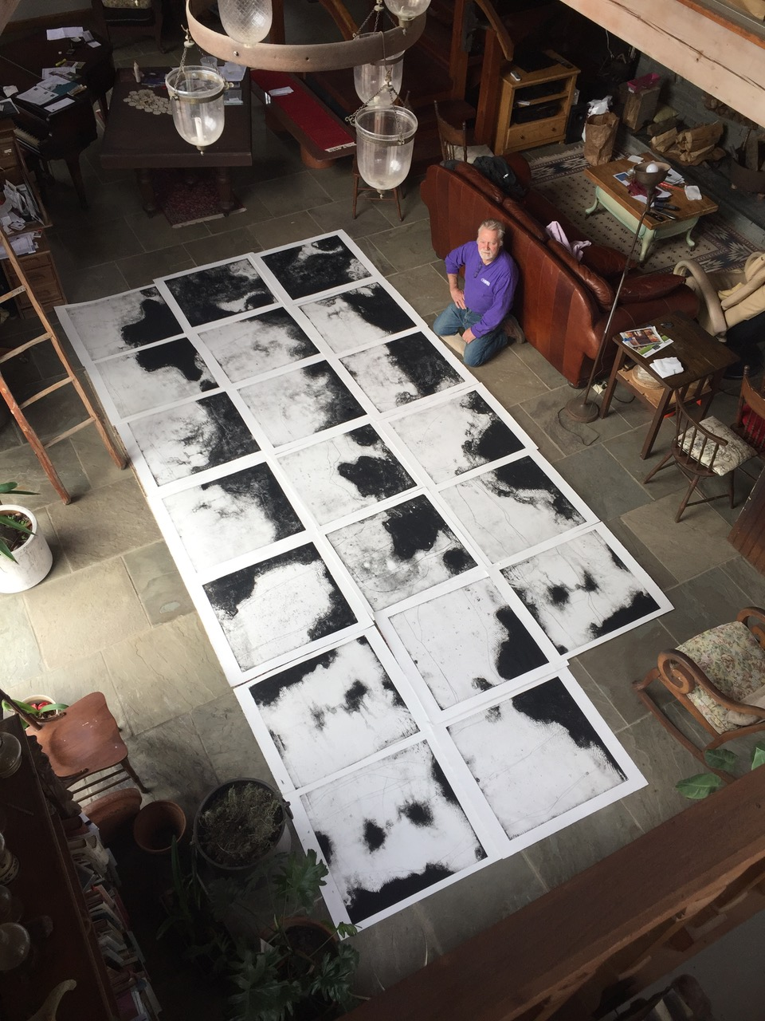

* Kevin and Kate will talk about Piedmont in November which is working out so I hear.
* Report on Themed Portfolio, Membership Engagement?

1. Journal/Advertising-Susan
2. Residence Program-Nikki
3. Treasurers Report-Nanette

**Next Meeting is Wednesday October 13, 2021**

End Meeting