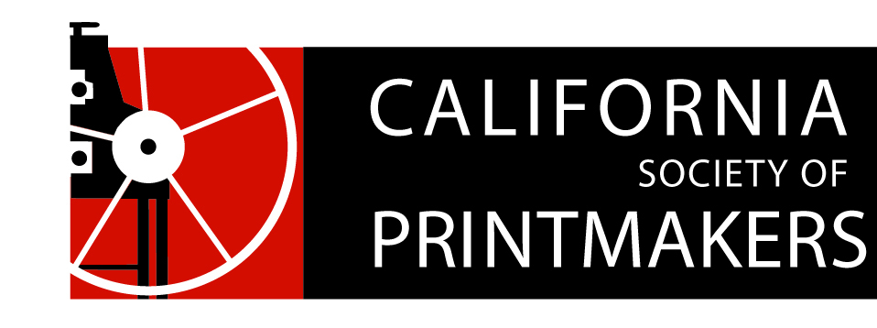

Proposed Board of Directors Ballot
Annual Meeting
Nahl Hall, College of Art, Oakland, CA
May 19, 2018

President:
Jami Taback
Write-In:

Vice President:
Dan Harrison (aka Hj Mooij)
Write-In:

Treasurer:
Nanette Wylde
Write-In:

Membership:
Rozanne diSilvestro
Write-In:

Secretary:
Maryly Snow
Write-In:

Webmaster:
Cynthia Rand-Thompson
Write-In:

Artist Memberships/Portfolio Review
Carrie Ann Plank
Write-In:

Exhibitions Director:
Joanna Kidd
Write-In:

Publications:
Bob Rocco
Write-In:

Social Media:
Michelle Wilson
Write-In:

Marketing:
Helene Coté
Write-In:

At-Large:

