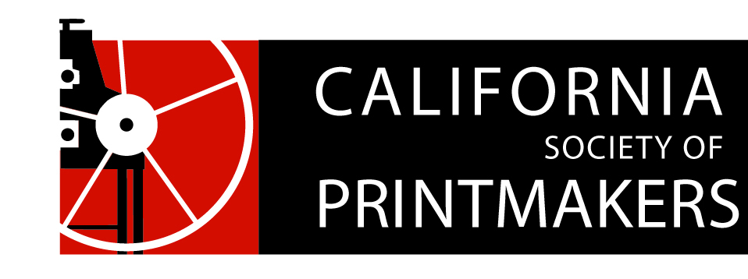

Proposed Board of Directors Ballot
Annual Meeting
Nahl Hall, College of Art, Oakland, CA
May 19, 2018

President
Jami Taback
Write-In: __________________

Vice President
Dan Harrison (aka Hj Mooij)
Write-In: __________________

Treasurer
Nanette Wylde
Write-In: __________________

Secretary
Maryly Snow
Write-In: __________________

Membership
Rozanne diSilvestro
Write-In: __________________

Webmaster
Cynthia Rand-Thompson
Write-In: __________________

Exhibitions Director
Joanna Kidd
Write-In: __________________

Artist Memberships
Carrie Ann Plank
Write-In: __________________

Portfolio Review
Carrie Ann Plank
Write-In: __________________

Social Media
Michelle Wilson
Write-In: __________________

Historian
Mary V. Marsh
Write-In: __________________

Publications Chair
Annie Pyke
Write-In: __________________

Publications Committee
Bob Rocco
Jan Cook
Meri Brin
Write-In: __________________

Special Events Director
Susan Howe
Write-In: __________________

Special Events Team
Ginger Tolonen
Open Position Write-In: __________________

Residency
Zach Clark
Write-In: __________________

Marketing
Hélène Paulette Côté
Write-In: __________________

Exhibition Committee
Melinda Whipplesmith plank
Colleen Sullivan
Ashley Rodriguez
Lola Fraknoi
Peter Foley
Open Position Write-In: __________________
At-Large Members
Peter Baczek
Meri Brin
Barbara Foster
Monica Farrar
Genviève L’Heureux
Write-In: __________________

