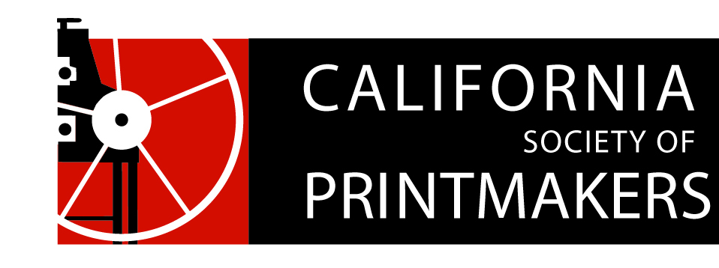

Proposed Board of Directors Ballot
Annual Meeting
Nahl Hall, College of Art, Oakland, CA
May 19, 2018

President
Jami Taback
Write-In: __________________

Vice President
Dan Harrison (aka Hj Mooij)
Write-In: __________________

Treasurer
Nanette Wylde
Write-In: __________________

Secretary
Maryly Snow
Write-In: __________________

Portfolio Review
Carrie Ann Plank
Write-In: __________________

Membership
Rozanne Di Silvestro
Write-In: __________________

Webmaster
Cynthia Rand-Thompson
Write-In: __________________

Exhibitions
Joanna Kidd
Write-In: __________________

Historian
Mary V. Marsh
Write-In: __________________

Publications
Bob Rocco
Write-In: __________________

Special Events
Susan Howe
Write-In: __________________

Residency
Zach Clark
Write-In: __________________

Social Media
Michelle Wilson
Write-In: __________________

Marketing
Hélène Paulette Côté
Write-In: __________________

At-Large (7 total)
Peter Baczek
Meri Brin
Barbara Foster
Monica Farrar
Geneviève L’Heureux
Write-In: __________________

Write-In: __________________

