**San Miguel de Allende Art Vacation**

**March 11 – 18, 2019**

***Glen Rogers leads you on a magical journey - in the printmaking studio and beyond. The Perfect Art Vacation!***

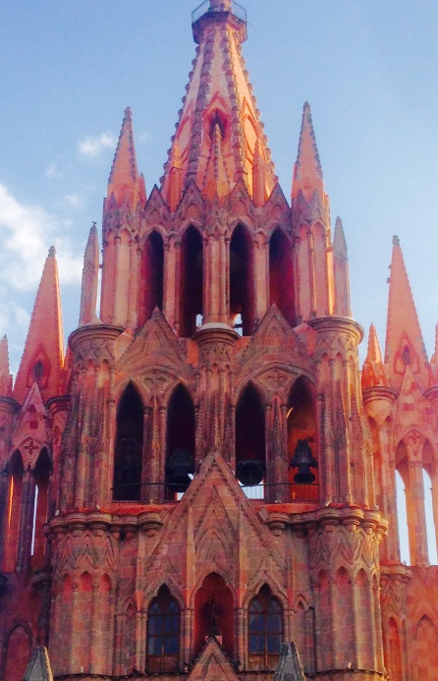 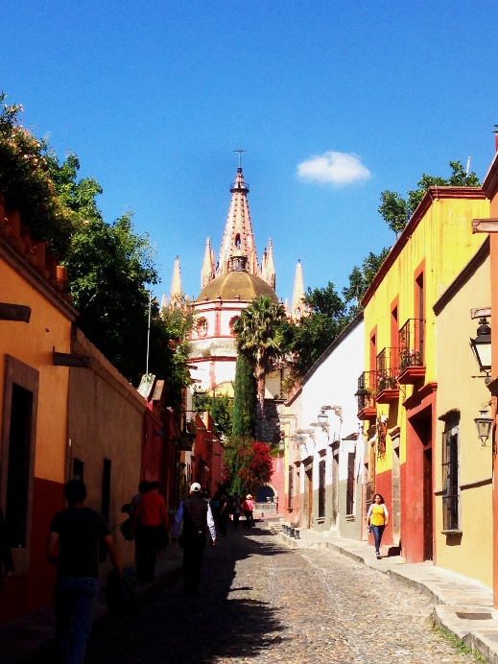

Join me in San Miguel de Allende, a beautiful colonial city in Mexico's central highlands known for its baroque architecture and thriving arts scene. San Miguel is a World Heritage Site and recently voted t*he best city in the world*by Travel & Leisure magazine. It is known for its creative cuisine, cobblestone streets and a treasure trove of shopping.

​

Get your creative juices flowing with a 5 day monotype workshop in my new studio in San Miguel - within walking distance to the Centro Historico. I will guide you on visits to galleries and introduce you to the best of the city. We will also visit Canada de la Virgin, an Otomi pyramid/archeological site.

Cost: $700USD includes all printmaking supplies and one large sheet of paper (22" x 30").  Additional paper may be purchased.

Does not include airfare or accommodations. ​Fly into Mexico City, Leon, or Queretaro - all require a bus ride to San Miguel.