**Extending Meaning: The Relief Print with Collage**

**Via Zoom!**

**With Robynn Smith through Blue Mouse Studios**

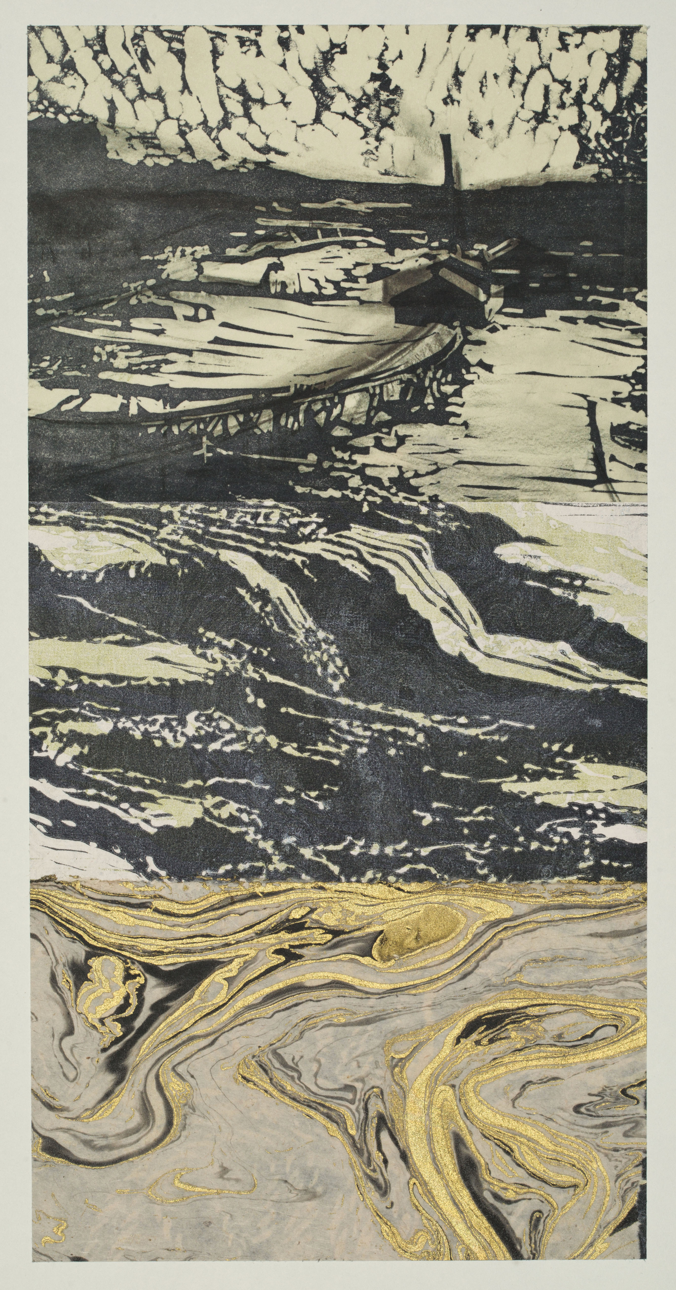Relief printing offers endless interpretive possibilities! Making multiples is quick and easy, with a press or printing by hand. With the addition of new printing techniques and collage elements, the mood and meaning of an image can change dramatically. We will explore the exciting possibilities of color, texture, and image manipulation, as we combine relief printing and collage in this Zoom workshop.

Zoom allows us to learn together from the comfort and safety of our home studios. Technical instruction, interpretive discussion and focused critique will be featured. We can even eat lunch together as the magic of Blue Mouse Studios extends to your personal workspace!

I’ve specifically selected this workshop content for the Zoom format. Instruction will be clear and well communicated. The workshop format will be well structured, with plenty of opportunity for group and individualized discussion.

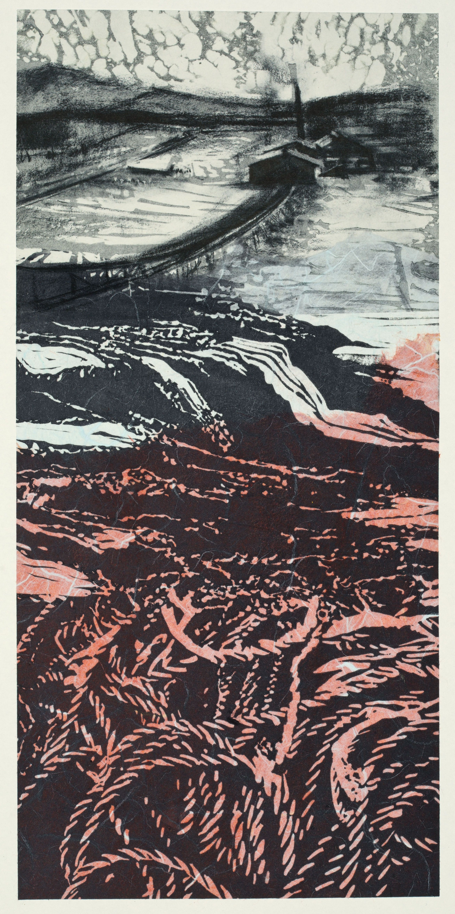

**Join me for a weekend of creativity and community!**

**Saturday and Sunday, August 29-30th**

**10:00-3ish**

**$150.00**

Space is limited!

Send your check to:

**Robynn Smith –Blue Mouse Studios**

**320 Day Valley Road**

**Aptos, CA 95003**

831-685-4723 or email robynn@cruzio.com

[www.robynnsmith.com](http://www.robynnsmith.com)