**[ARTS & CULTURE](https://www.kqed.org/arts)**

**After Wildfire, a Family of Artists Faces the Cultural Losses of Climate Change**

[Nastia Voynovskaya](https://www.kqed.org/author/nvoynovskaya)

Sep 4

* Facebook
* [Twitter](https://twitter.com/intent/tweet?url=https%3A%2F%2Fwww.kqed.org%2Farts%2F13885467%2Fafter-wildfire-a-family-of-artists-faces-the-cultural-losses-of-climate-change&text=After%20Wildfire%2C%20a%20Family%20of%20Artists%20Faces%20the%20Cultural%20Losses%20of%20Climate%20Change)
* [Email](mailto:?subject=Check%20out%20this%20article%20from%20KQED&body=https%3A%2F%2Fwww.kqed.org%2Farts%2F13885467%2Fafter-wildfire-a-family-of-artists-faces-the-cultural-losses-of-climate-change)
* Copy Link

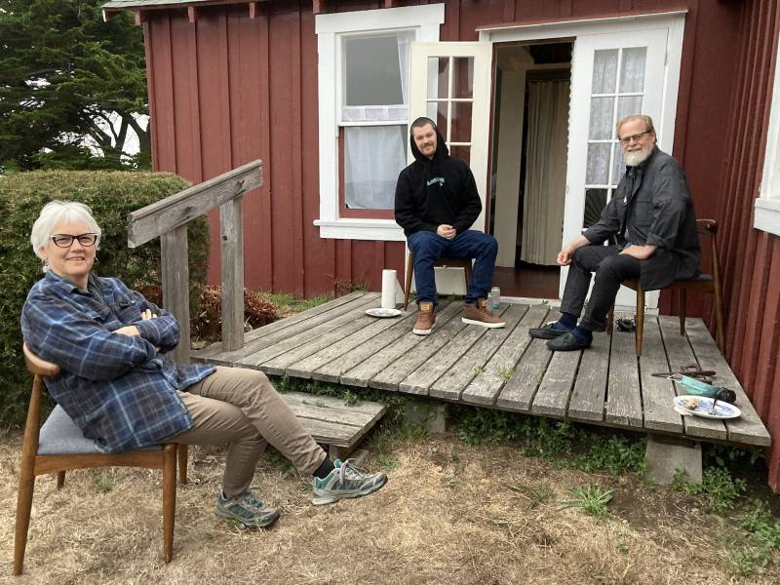

Book artist Felicia Rice (left), music producer Wax Roof (center) and scientist Jim Schoonover lost their family home in the CZU Lightning Complex Fire. *(Courtesy of the Rice Schoonover family)*

**F**

elicia Rice’s husband, Jim Schoonover, often joked that the house they rented in the Santa Cruz mountains was really a one-bedroom apartment above her business, [Moving Parts Press](https://movingpartspress.com/" \t "_blank).

Over the 25 years the family lived there, the book artist, publisher and former UC Santa Cruz administrator filled the downstairs with three vintage letterpresses, 190 cases of metal type and her personal collection of limited-run poetry and art books she’d published since starting her business in 1977. Paintings by her parents, artists who worked closely with the apprentices of Frida Kahlo and Diego Rivera, were lovingly kept there, as well as irreplaceable ancestry records and family photos.

The Schoonover Rices’ younger son, Will, the Oakland music producer [Wax Roof](https://waxroof.bandcamp.com/" \t "_blank), grew up in that house from the age of seven, watching his mother juggle the many roles involved in turning a niche art form into a thriving business. (His older brother, Gabe, was already in his late teens when the family moved there from Santa Cruz proper.) Felicia’s creative hustle inspired Will’s path toward guitar, trumpet, piano and music production for stand-out Bay Area hip-hop artists like [Rexx Life Raj](https://www.kqed.org/arts/13869513/rexx-life-raj-father-figure-3-empire" \t "_blank) and Caleborate.

The Schoonover Rices’ woodsy home in the small, secluded community of Bonny Doon was sacred to three generations of creatives—but more than that, it held the memories that shaped them as people, as artists and as a family. And now it’s gone, along with the 1,000 structures burned in the CZU Lightning Complex Fire.

“The one thing that brings tears to my eyes is my community,” says Felicia. “My neighborhood is completely devastated. Everything is ash on the ground.”

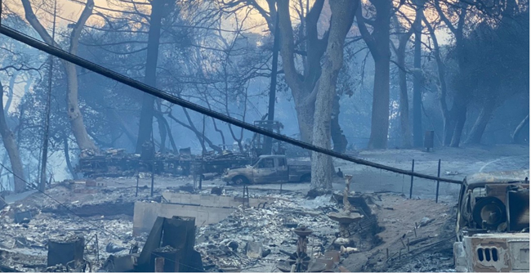Bonny Doon after the fire. *(Moving Parts Press)*

**B**

onny Doon only had about 2,600 residents, and Will describes it as a self-reliant community where working-class people, university-affiliated intellectuals and hippie artists lived side by side. “When you have a place that’s founded on the concept of ‘you can be what you want to be here,’ you end up having a lot of different types of folks,” he says.

That open-mindedness is what drew Felicia to Santa Cruz in the ’70s, when she found a “mutually beneficial economy” of underground artists and poets who supported one another’s work and helped her printing business thrive. “We were creating community and creating culture,” she says.

Over the years, that tradition continued. Growing up in the ’90s and early 2000s, Will encountered many generous neighbors who took the time to teach him music or join in spontaneous jam sessions, for whom music was a way of life and not just a hobby.

“I don’t want to talk about it in the past tense like it’s gone,” he adds with a sadness in his voice.

He recalls a childhood of roaming the land, feeling a sense of freedom while running through the trees. The stories that stick out in his memory show the ways the community raised him to value creativity and generosity: When he was 13, playing guitar in the woods at night, a neighbor in a nearby house joined in on trumpet—without ever showing their face.

“To have someone just be there, ready, to have a musical conversation with me when I didn’t know what I was saying—and them never needing to be seen or acknowledged—that speaks a lot to the integrity of the place to me,” he says.

Sponsored

When he was in high school, a UC Santa Cruz student taught him flamenco guitar for a few bucks an hour; a Turkish family introduced him to the collaborative improvisation of Romani music; and a Brazilian guitarist played in a hospital room while Will said his final goodbyes to a friend with cystic fibrosis.

In Bonny Doon, it was “normal to be in this musical exchange, with no purpose other than it makes life better,” Will says, reflecting that these experiences made him a better artist. Bonny Doon fed Felicia’s art, too; when she relocated her print shop there, the ink she mixed became more vivid, inspired by the local grass, leaves and branches interacting with the changing sky. The resulting illustrations made her poetry books come alive.

“You fall in love with that land, that land holds you,” says Will. “Being on a mountain with redwoods ... and it goes all the way down to the ocean where there’s water as far as you can see, and there’s rivers running down into to that. ... There’s this huge vastness of space that, when you lean into it, it embraces you.”

“And I think that’s why people tend to be more free-thinking or tend to embrace individuality,” he says. “You look out and you don’t see the hard lines of these systems of man that are either in a state of repair or in disrepair.”

**W**

hen the blaze spread into the Santa Cruz mountains in mid-August, Felicia was at her late parents’ home in Mendocino, taking a self-prescribed artist retreat and thinking about her next book, *Justice & Injustices*—which, appropriately enough, deals with the intersecting issues of climate change, capitalism and oppression. (“From Trump through COVID through George Floyd and others, systemic racism, to what’s gonna happen next—wildfire is part of it, fire is part of it,” she says.) Jim had stayed behind, not wanting to take his chances traveling during the pandemic because of a health condition.

The summer was uncharacteristically hot for Bonny Doon; stretches of days had over-100-degree weather. When sparks ignited after an unlikely August lightning storm, wildfire season started early. Firefighting crews in California were stretched thin because the pandemic made the state’s strategy of deploying [incarcerated firefighters](https://www.kqed.org/science/1968728/shortage-of-inmate-firefighters-hampers-response-in-bay-area" \t "_blank) untenable.

**[Let's Talk About Wildfires and Prisons](https://www.kqed.org/arts/13885195/lets-talk-about-wildfires-and-prisons" \o "Let's Talk About Wildfires and Prisons)**

Neighbors in Bonny Doon assembled [volunteer fire crews](https://www.kqed.org/news/11835949/most-beautiful-place-on-earth-the-citizen-firefighters-who-stayed-behind-to-save-their-santa-cruz-mountain-paradise" \t "_blank). One retired firefighter who lived nearby called Jim on Aug. 19 and told him that flames were approaching. He drove off at midnight, packing little more than important documents and clothes for him and Felicia.

The next night, the couple found out from neighbors that their house had burned to the ground along with nearly two dozen neighboring properties.

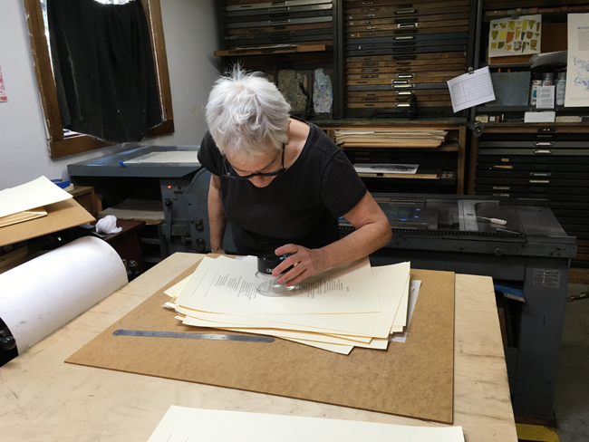Felicia Rice at work in Moving Parts Press. *(Moving Parts Press)*

Gone were floor-to-ceiling paintings by Ray Rice, Felicia’s father. Gone was an edition of a book by Miriam Rice, Felicia’s mother, who was best known for extracting a full color spectrum of natural dyes from mushrooms. (“That can be reprinted, so all is not lost,” Felicia sighs.)

A vast archive of Felicia’s artworks and collaborations burned too, including a book called *[Califas: The Ancestral Journey/El Viaje Ancestral](https://movingpartspress.com/publications/califas" \t "_blank)*, a collaboration with five artists that folded out into an 18-foot, movable mural. Hand-bound copies—750 of them—were set to go out to K-12 and university classrooms, youth organizations, museums and libraries. A [broadside series](https://movingpartspress.com/publications/latinx-chicanx-poetx-broadside-series" \t "_blank) of queer Latinx poetry is mostly gone. And she lost 3/4 of a print run of a collaboration with environmental activist and art historian T.J. Demos, *[The Necropolitics of Extraction](https://movingpartspress.com/publications/necropolitics-of-extraction" \t "_blank)*—about capitalism’s exploitation of human labor and natural resources.

“I was just starting to sell them, and that’s heartbreaking because one book funds the next,” she says. There is a small silver lining, though: thanks to her supporters, Moving Parts Press recently raised enough on [GoFundMe](https://www.gofundme.com/f/raise-moving-parts-press-from-the-ashes" \t "_blank) to buy back crucial equipment. With the ongoing campaign, Felicia now hopes to raise enough—$75,000—to create a new printing studio in Mendocino.

**T**

oday, the CZU Lightning Complex Fire is just over 40% contained, and it may be weeks until it’s safe to drive 2,500 feet up the mountain on a narrow, two-lane road to assess the damage or find anything that may have survived the flames.

Because the Schoonover Rices were renters, they don’t have to deal with the fallout of calling insurance companies or deciding whether or not to rebuild. But they’re still grappling with the emotional loss of saying goodbye to a community that nurtured them for decades. Despite their success in the arts, Bonny Doon home prices were never attainable for the family. Before the fire, houses in the Santa Cruz mountains neared the $1 million mark. Those now displaced may not be able to come back.

“There’s a lot of people living out here that when they lose that [their home], it’s done for them,” Bonny Doon resident and volunteer firefighter Glen Hanson [told KQED](https://www.kqed.org/news/11835949/most-beautiful-place-on-earth-the-citizen-firefighters-who-stayed-behind-to-save-their-santa-cruz-mountain-paradise" \t "_blank) in August.

For Will, that loss has been difficult to put into words. “Something I’ve been mourning that’s hard to articulate is the concept of when you lose someone, you’re able to be who they were to you to other people and, in that way, keep their legacy alive,” he says. “When you lose a place, I’m left with the question of how you’re supposed to do that.”

For Felicia’s part, she’s getting back to the basics, figuring out her new routine in Mendocino and taking the rebuilding of Moving Parts Press step by step. But she knows the losses of her house and Moving Parts Press are emblematic of a larger reality: climate change is devastating people and communities. Along with destroying homes and livelihoods, wildfires take history and culture with them. She worries about how bad it will get before meaningful steps are taken. She wants to see our elected officials take serious action on climate change.

“Let’s not get cozy. Let’s not get comfortable. This isn’t a comfortable time. Guillermo Gomez-Peña says our job as an artist is to keep the wound open, to remind people of these realities,” she says.

“I would like political leaders not to get in office on the basis of the platitudes and reassurances they give, but on the basis of their policies and plans to address the real dangers and threats that are a part of our world.”