*As appeared in*

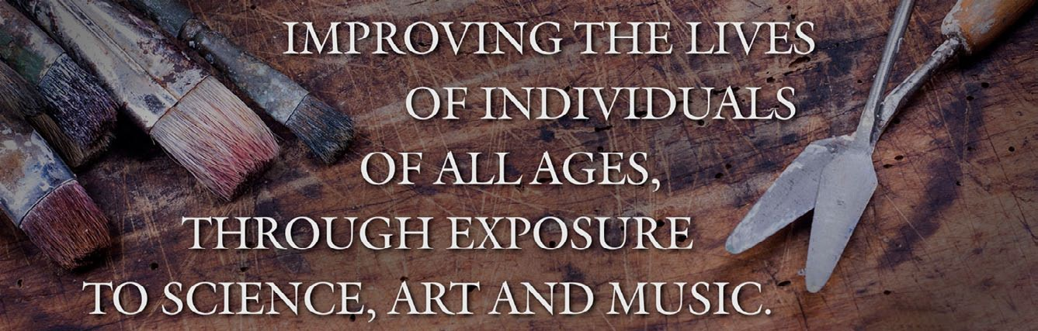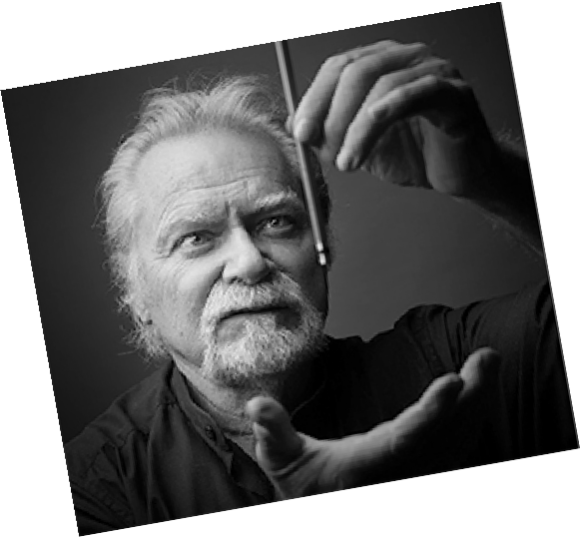

***Journal of the Print World***

$2500 Inspiration Plus Grant

The $2500 Inspiration Plus Grant is intended for an established skilled independent printmaker proficient in all aspects of the craft. Working residents would

be required to produce a science related art proj- ect involving printmaking with environmentally safe con- sciousness during the 3-6 month residency. Work will be shared in the Sag Harbor studio of Dan Welden with the possibility of an exhibition in his Studio/Gallery.

Applicants must submit a statement of intent including any outreach projects or teaching for the benefit of “Inspira- tion Plus;” 6-10 images; a list of 3 references; and a brief resume. Please include a $25 non refundable application fee check, payable to Inspiration Plus Foundation. Foreign applicants may make arrangements through PayPal.

The program is designed as a win-win situation where the artist will benefit from their own experience as well as be- ing in a professional working situation in a serene studio.

Applications should be addressed to Mindy Kronenberg, Chair.

***Mindy Kronenberg*** [***cyberpoet@optonline.net***](mailto:cyberpoet@optonline.net)[***https://www.inspirationplus.or***](http://www.inspirationplus.org/)***g/***

**Deadline extended to November 15**