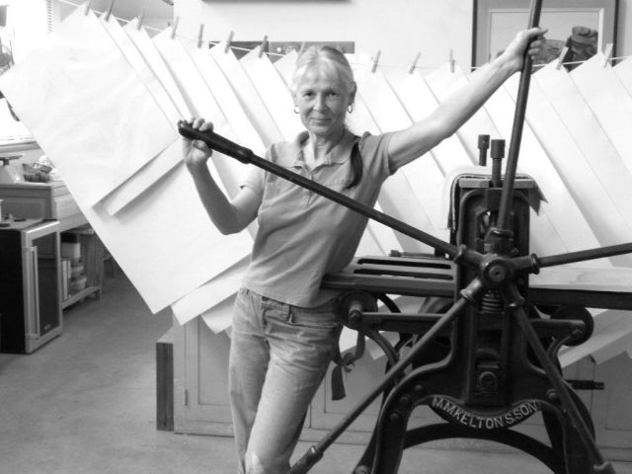

**Katherine Venturelli** is known for creating unique mixed media artist’s books and fine prints produced from her Northern California printmaking studio. Her works are held in numerous museums and special collections throughout the United States which include the Palace of the Legion of Honor (San Francisco); the Getty Museum Research Institute; Museum of Fine Arts, Santa Fe; Walker Art Center (Minneapolis); Crocker Art Museum (Sacramento), and the Special Collections of U.S.C, Mills College, Univ. of WA.; RISD; Janet Turner Print Museum; the Reva and David Logan Collection, and the Mary Austin Collection. Her print work was exhibited in the 2001 California Palace of the Legion of Honor’s “Contemporary California Works on Paper”. Other museums exhibiting her work include 2017, “MUSUBU-Book Arts”, Urawa Art Museum, Tokyo, Japan; 2018, “Thinking Outside the Frame”, NUMU Museum, Los Gatos; and the 2019 “Regional Collective”, Janet Turner Print Museum, Chico. Noteworthy publications: “PAGES; Innovative Bookmaking Techniques”,1997; “100 Santa Fe Etchers”, 2008; “500 Handmade Books”, Vol. II, Lark Publishing, 2013; “California Society of Printmakers: One Hundred Years, 1913–2013”.

**General Statement:**

Having a sculptor’s orientation and education as her foundation, Venturelli creates prints using multiple copper plates and abundant colors, combining a spectrum of graphic techniques including etching, drypoint, aquatint and monotype. Sometimes the printing matrixes are cut, thereby creating the possibility of many more print variations and permutations, or they find themselves re-cycled into 3 dimensional forms. All her prints are hand pulled on her studio presses. “My art making emphasis has evolved towards integrating two dimensional prints into three dimensional forms, thus an attraction to the artist book genre as both physical objects and containers of meaning. The power of metaphoric imagery and the elegance of mathematics have inspired and inform my work. The physical world offers me complex relationships and rich metaphors which I thrive in exploration.”

**For inquiries and Studio Visit Contact:**

**209-245-6002/ 209-267-0567**

**kventurelli47@gmail.com**

Website: katherineventurelli.com