**The Tannery Studios**

**Wooden Board Bookbinding Class**

**June, 2023**

**Nicky Yeager:** [**nixels@mac.com**](mailto:nixels@mac.com)

This workshop is geared towards making the best sketchbooks you'll ever own. After you know how, you can make successive bindings using your favorite paper, and in any size you want. The techniques are translatable, and you won't need any more tools* than you already have!

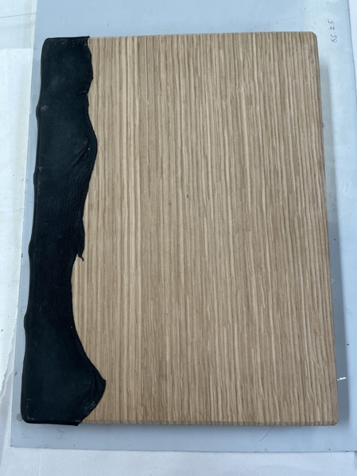

The medieval book was built to last. The revolutionary technology embedded in this form has been around for close to 1200 years. Since then, there’ve been a few upgrades in communication technology, but for portability, durability, ease of use, and secure storage of the contents within, there’s nothing better than a wooden-board binding. And now, that technology is within easy grasp after a couple of days of making your first quarter-leather, laced-on-wooden boards bookbinding!  
 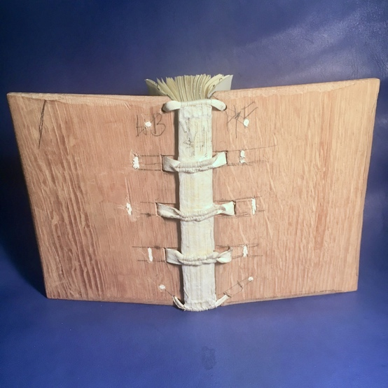

In this 2-day class, you’ll make a 6” x 9” medieval-style binding that will open flat – and is almost indestructible! The 128-page (8 signatures) textblock will be sewn on leather supports and laced into shaped wooden boards. After folding paper into 16-page signatures, we’ll punch them at the fold, in preparation for sewing. Making the leather thongs, and sewing the textblock onto them brings the book into an identifiable form. To consolidate it into a book, we'll glue up the spine while adding a linen spine liner.

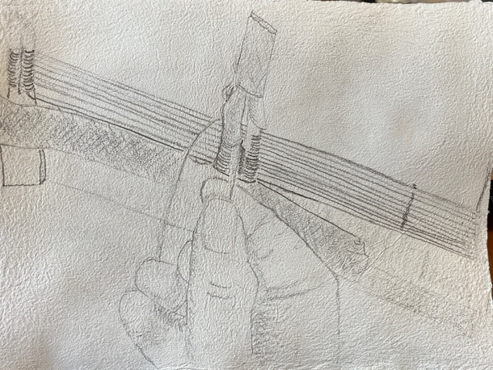

As the glue dries, we'll shape the boards with wood-planes and chisels. Channeling the boards to accept the leather thongs, drilling holes to lace the thongs, and lacing the boards onto the textblock brings the parts together to make a book.

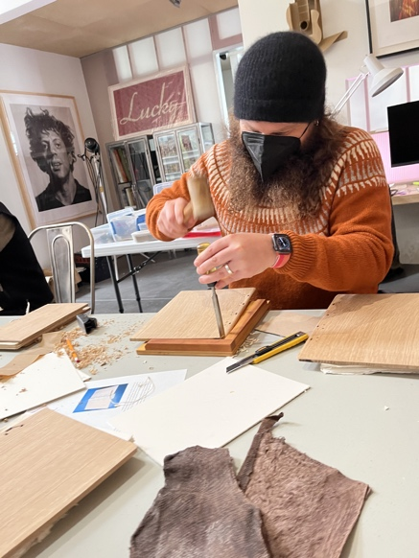

Covering the spine with leather, turning it in top and bottom, and shaping the leather over the cords gets us closer to the final product. Pasting down the endsheets, and blind tooling the leather finishes the work. When completed, you'll know how to make this structure, and I'll supply you with variants, suppliers, and a list of materials so that you can do this on your own.

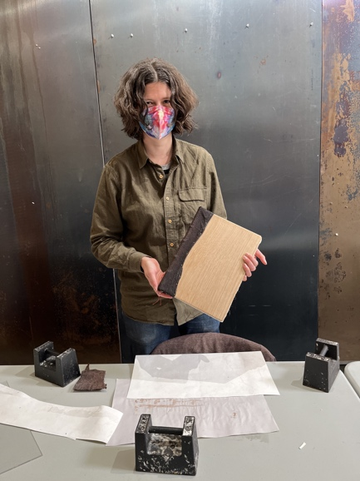

The fee is: $335 for 2 full days of class. This includes oak boards, leather, tools and materials to take the class.

*\*Tools to bring, if you have them: Scissors, bone folder, awl, Olfa click-knife, leather mallet.*

**Contact me through email: Nicky Yeager:** [**nixels@mac.com**](mailto:nixels@mac.com)**. Phone: 510.606.0383**

**Payment:**

**Paypal:** [**nixels@mac.com**](mailto:nixels@mac.com)

**Venmo: @Nicholas-Yeager-2 (last 4 of phone: 0383)**

**Zelle: My email for that is: nicholasg.yeager@gmail Phone: 510.606.0383**

**I am happy to answer any questions you have about the class.**