Graphic Arts Workshop

2565 Third St., #305

San Francisco, CA 94107

Introduction to photopolymer plates

2 Saturdays, April 6 and April 13, 10-4pm

Instructor: Mark Brodie

Dates: April 6 and 13, 10AM-4PM

Prerequisite: Basic concept of printmaking

Class Tuition: $225 (minimum 4 people, maximum 8)

Material fees: $55, which will include 3 small photopolymer plates, transparency sheets for

Transferring images, paper, ink, tools, supplies.

Registration and payment: Email [msbrodie@aol.com](mailto:msbrodie@aol.com). To register and get payment info.

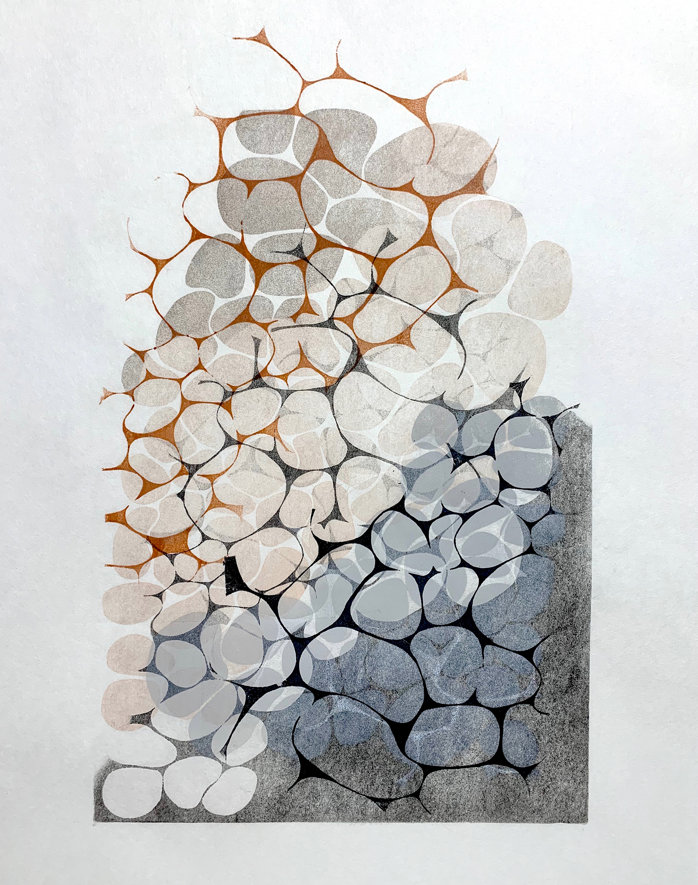

Images of Mark’s work on Instagram: markbrodie1111

**Day 1: Relief plates**

* Review a variety of relief and intaglio prints created with photopolymer plates
* Work on ideas for a relief plate, create and print the plate
* Begin generating ideas for creating an intaglio plate for second day of workshop.

**Day 2: Intaglio plates**

* Print transparencies for those that have not been able to do so during the week
* Demonstrate the double exposure technique utilizing an aquatint screen
* Participants expose their plates, and print
* Class review