Blue Mouse Studios Solar Plate Print Camp
Four days of demos, instruction, guidance, and camaraderie
with Robynn Smith
Blue Mouse Studios, Aptos, CA

July 22-25, 2014 (with optional extra day of printing!)
10am-4pm
Join the gang at beautiful Blue Mouse Studios for an inspiring and productive Solarplate intensive workshop. Learn how to make plates using the sun, a light box and an exposure unit. Learn traditional inking and printing as well as experimental ways of using these very versatile plates. All kinds of imagery is welcome, from photographs to drawings to stencils and collage. Workshop participants may choose to explore all techniques or use the class to concentrate on one or two. Demonstrations will be followed each day by individualized instruction.
Solarplates may be combined with the following techniques to create prints of depth and unexpected beauty:
Monotype, collograph, relief printing, pastel transfer, chine colle, viscosity inking, multiple drop printing, layering processes and experimentation. Note the versatility below!

Solid instruction and a bit of Blue Mouse magic promise an exciting and productive workshop.

Camp tuition: $460. Optional day of printing on Friday July 26 @ $75.
Basic studio supplies are provided.
Plates and paper will be available for purchase.

Space is limited so we can all work safely. Send your $100 deposit to:
Blue Mouse Studios robynn@cruzio.com
320 Day Valley Road www.robynnsmith.com
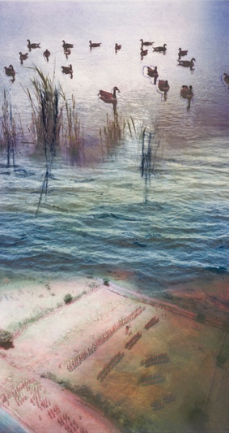
Aptos, CA 95003 408-482-9802
