Monotype Workshop @ Graphic Arts Workshop
Saturday and Sunday February 15 &16, 2025,
10AM -4PM
Instructor: Kathryn Kain

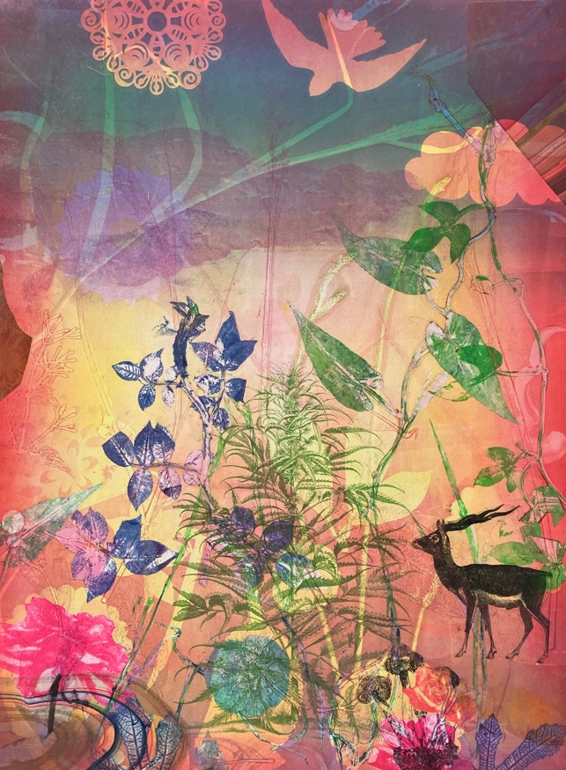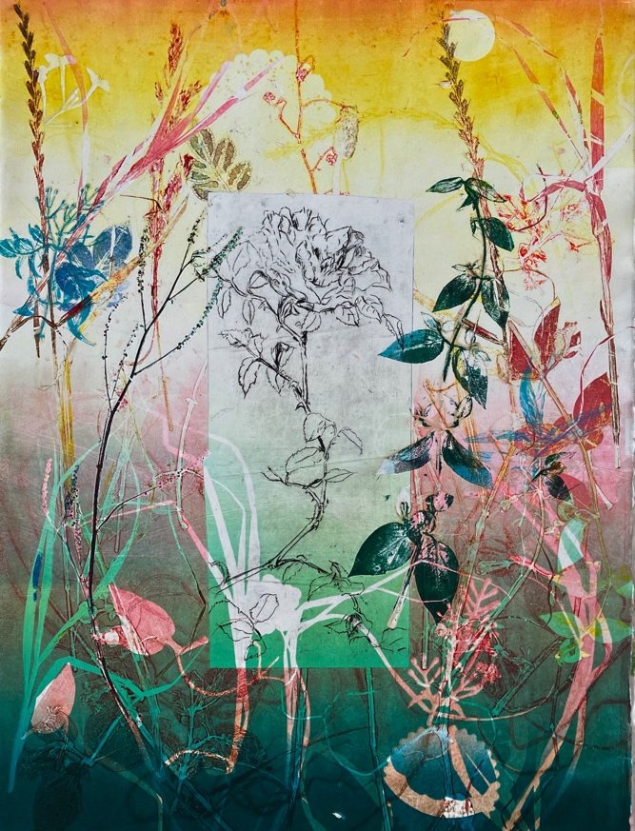

Amethyst Crystal, Monotype, 30 x 22” 2022 Sunset Rose, Monotype, 30 x 22” 2019

Contact: Kathryn Kain, kk@cailech.com, kathrynkain.com, 408-230-8629
Any questions and concerns, email or text to set up a call.

$200 for 1 day
$300 for 2 days

Payment by cash or check is preferred, Venmo, debit cards & credit cards possible.

Maximum 8 participants per day, people taking both days will be given priority.
Make monotypes using oil-based printmaking inks. Work with reductive and additive monotype techniques as well as transparent roll ups, botanical images, chine collé,
stencil and photocopy gum transfers.
Inks -oil based full color palette of inks modified for monotype available.
Prepared damp Rives BFK in full, ½ and ¼ sheets @ $6.00 per sheet
Rives BFK sheet sizes: Full 30 x 22.5” Half 22.5 x 15” Quarter 15 x 11.25”
Custom sizes are fine if they are not larger than a full sheet.

Clean-up will be done with vegetable oil and Simple Green.
The format you choose is open, I’ll set up a template to print your plate.
Choose from a full bleed format with no margins or a format with margins

Bring a plexi plate, it’s nice to have two matching plates, 1/16” thick clear acrylic or polycarbonate. The thin plates are easy to bevel with an etching scraper. Bleed format plates need to be 1-2” larger than paper size

Bring lunch!

Please bring white or light T shirt rags cut to approximately 6 x 6”
Optional supplies:
Your labeled brushes and brayers
Japanese paper for chine collé,
B&W photocopies or laser prints for gum transfers, a small sponge
Commercial plastic stencils or handmade mylar or paper stencils.
Mylar for stencils
Gloves and apron
Black sharpie

.

