Creative Explorations in Printmaking
Four Days of instruction, inspiration, demos, support and camaraderie
with Robynn Smith at Blue Mouse Studios, Aptos, CA

4 days of intensive, individualized printmaking guidance and instruction in a wide variety of techniques. This workshop is suitable for all levels of experience.

January 12-15, 2026
10am-4pm

Are you new to printmaking and want to be exposed to various techniques? Are you an experienced printmaker with a project in mind? Do you need a little push or a jump into the deep end? This workshop is tailored to the needs of individual participants. Together we will push boundaries, ignite ideas and explore new approaches.

Bring ideas and goals, images, unfinished or “failed” prints and plates, collaborative projects, “how to” questions and wish lists. We’ll work together to answer your questions and realize your ideas. Concentrate on one technique or try several. Solid instruction, support, creative thinking and a bit of Blue Mouse magic promise an exciting and productive workshop.

Blue Mouse Studios is equipped for linoleum and woodcut, monotype, monoprint, Solarplate, collage, collograph, chine colle, pastel transfer, viscosity inking, hand coloring and related, combined techniques. We can layer processes and experiment together. Demonstrations will be followed by individualized instruction. Blue Mouse is a well-equipped studio using high quality, nontoxic inks.

Workshop tuition $450
Basic studio supplies are provided, Paper, blocks and plates will be available for purchase.

Space is limited so we can all work safely and comfortably.
Send your $100.00 deposit to Blue Mouse Studios, 320 Day Valley Rd., Aptos, CA 95003
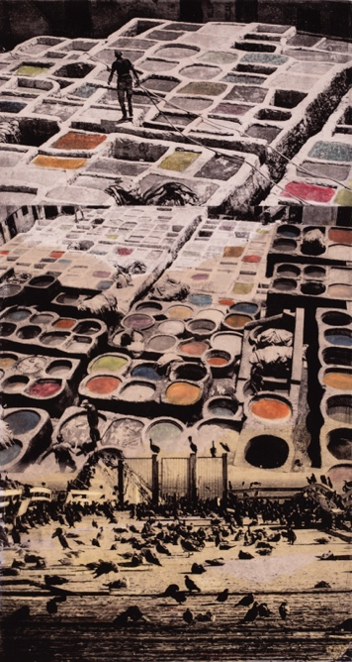
robynn@cruzio.com www.robynnsmith.com 408-482-9802

