Reduction Linocut Intensive
With British Linocut Master Martin Truefitt-Baker
Assisted by Robynn Smith at Blue Mouse Studios, Aptos, CA

September 12-15, 2026
10am-4pm

4 days of instruction including image development, carving, registration techniques, inking and printing
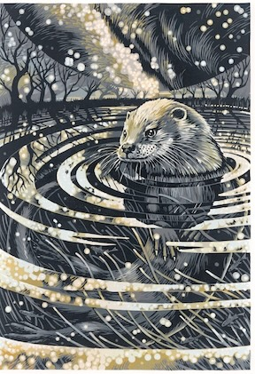
Reduction lino printing is an exciting process that combines thoughtful planning with the unexpected and serendipitous. Dubbed “Suicide Block” by Picasso, reduction lino uses just one block that is carved, inked, carved away and inked again. Colors and shapes build up as the block is carved away to nothing. This magical process can be used to create simple or complex imagery with luscious mark making and color arrangements.

Martin’s detailed reduction linocut prints are inspired by the magnificent flora and fauna of Wales. He has developed unique carving and inking techniques that allow him to catch the mystery of the way animals move and live within their environment. A gifted teacher, Martin is coming across the pond to share his techniques and creative process with eight printmakers at lovely and well-equipped Blue Mouse Studios. Be one of the lucky eight!

Participants will design and print a small edition of a three (or more) layered reduction lino prints, developing skills in planning, carving, inking and printing that will inform many additional printmaking practices. With Robynn’s assistance, Martin will individualize instruction, allowing participants to work toward an outcome that suits their own creative aims and practice.
Participants will be sent notes prior to the workshop, so that participants can develop a design in advance. They are welcome to correspond with Martin before the start of the course.

Workshop tuition $475
Basic studio supplies are provided, Paper and lino will be available for purchase.

Space is limited so we can all work safely and comfortably.
Send your $100.00 deposit to Blue Mouse Studios, 320 Day Valley Rd., Aptos, CA 95003
robynn@cruzio.com www.robynnsmith.com 408-482-9802

https://www.truefitt-baker.co.uk/

