ARTIST'S STATEMENT

The work in this exhibition goes back to a late evening on the beach in May of 2013 in Etretat, France, where I took a photograph of my shadow with the sun setting behind me. It was so elongated and totem-like, I knew it would become dwarfed on my litho stone. Back home, I transitioned from the heavy litho stones to a new, untested medium: large panels of Formica, a surface relegated to kitchen counters, but with a hardness and grain mimicking limestone.
All the work here, spanning ten years, from 2013 to 2023, is executed on Formica. The shift in medium felt like taking off my training wheels, with the new surface leading to distinct new work, an uncommon fusion of printmaking techniques and painting. It also allowed me to access more intense subject matter — as if a deeper drill could reach a deeper self.

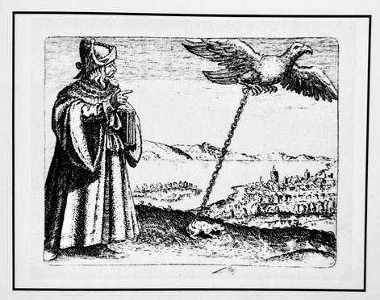

I have pinned on my studio wall a page from Michael Maier’s book of emblems, “Atalanta Fugiens.” (1617) It depicts Avicenna, an eleventh century Persian philosopher and physician, pointing to an eagle high in the sky, but an eagle tethered by a heavy chain to a terrestrial creature below, a lowly toad. It captures the need for the spirit to remain earthbound, for the mind not to abandon the world of matter. The image serves as a warning to me: starting in 1985, for twenty-five years, that heavy chain was thin as twine for me, a connection easily torn — it spelled hospitals, doctors and medication, the flight of a mind no longer in touch with this world. The medical label was “unipolar, prone to mania.” But to an artist, this “illness,” these experiences of walking outside of the house of thought are a gift, albeit a weighty one — not unlike a young soldier receiving a magnificent sword, but one too heavy and unwieldy. It comes with a wellspring of images, and leads to a lifelong quest for objective correlatives in the natural world that might approximate that otherworldly experience. Mania erodes the underpinnings of the very structures of thought, not unlike a violent storm, wiping out the scientific instruments of measure. It is difficult to map territory that defies mapping, to translate from a language that defies meaning. Can a soul out of bounds lasso itself? And yet, that is the task of the artist, to soar beyond the range of sight and then to come down to earth, to the studio, to a blank surface, and translate that vision into a work of art. Avicenna also foregrounds the role of the lowly toad: without her, the flight of the eagle would go unnoticed, unrecorded. An artist must be both soaring eagle and plodding toad.

From the introduction of my book After the Storms. Work from 2013 to 2023. With Excerpts from the Artist’s Notebooks. Available as softcover or PDF on Blurb.com. The book features all the work in this exhibition, with ten pages of artist’s notes.
Herlindespahr.com

