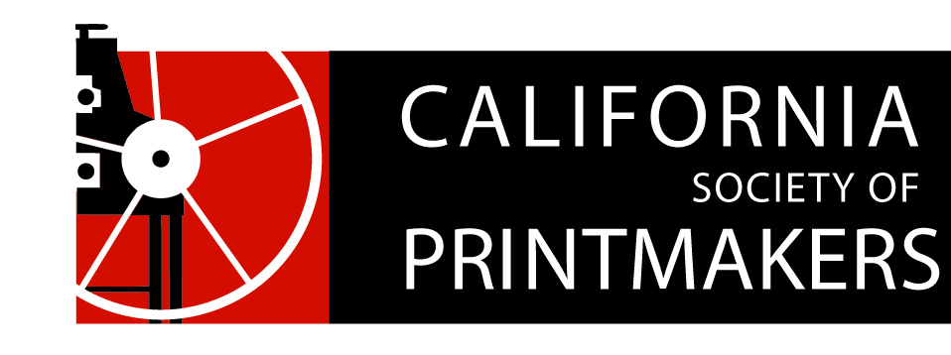

Proposed Board of Directors Ballot

Annual Meeting

Nahl Hall, College of Art, Oakland, CA

May 19, 2018

Circle a name or write one in!

**President**

Dan Harrison (aka Hj Mooij)

Write-In: __________________

**Vice President**

Write-In: __________________

**Treasurer**

Nanette Wylde

Write-In: __________________

**Secretary**

Maryly Snow

Write-In: __________________

**Portfolio Review**

Carrie Ann Plank

Write-In: __________________

**Membership**

Rozanne Di Silvestro

Write-In: __________________

**Webmaster**

Cynthia Rand-Thompson (not as a board position)

__________________________

Write-In: __________________

**Exhibitions**

Joanna Kidd

Write-In: __________________

**Historian**

Jami Taback

Write-In:_________________

**Publications**

Bob Rocco   
Write-In: __________________

**Special Events (Studio Visits, Guest Speakers, etc)**

Write-In: __________________

**Residencies**

Zach Clark  
Write-In: __________________

**Social Media**

Michelle Wilson

Write-In: __________________

**Marketing**

Write-In: __________________

**At-Large (7 total)**

Peter Baczek  
Barbara Foster  
Geneviève L’Heureux  
Write-In: __________________

Write-In: __________________

Write-In: __________________