Drawing Workshop!
Learning How to See with Robynn Smith
at Blue Mouse Studios, Aptos CA

Drawing is my first love, and I’m excited to announce this summer 2018 workshop at Blue Mouse Studios!

*All levels of experience welcome
*Observational and expressive techniques of drawing and composition
* Use of drawing materials such as charcoal, ink, pencil, conte, etc.
*Personalized instruction
*Inspiring environment, great facilities

Saturday and Sunday, July 14 & 15th
10:00-4:00
$175.00 includes most materials!!
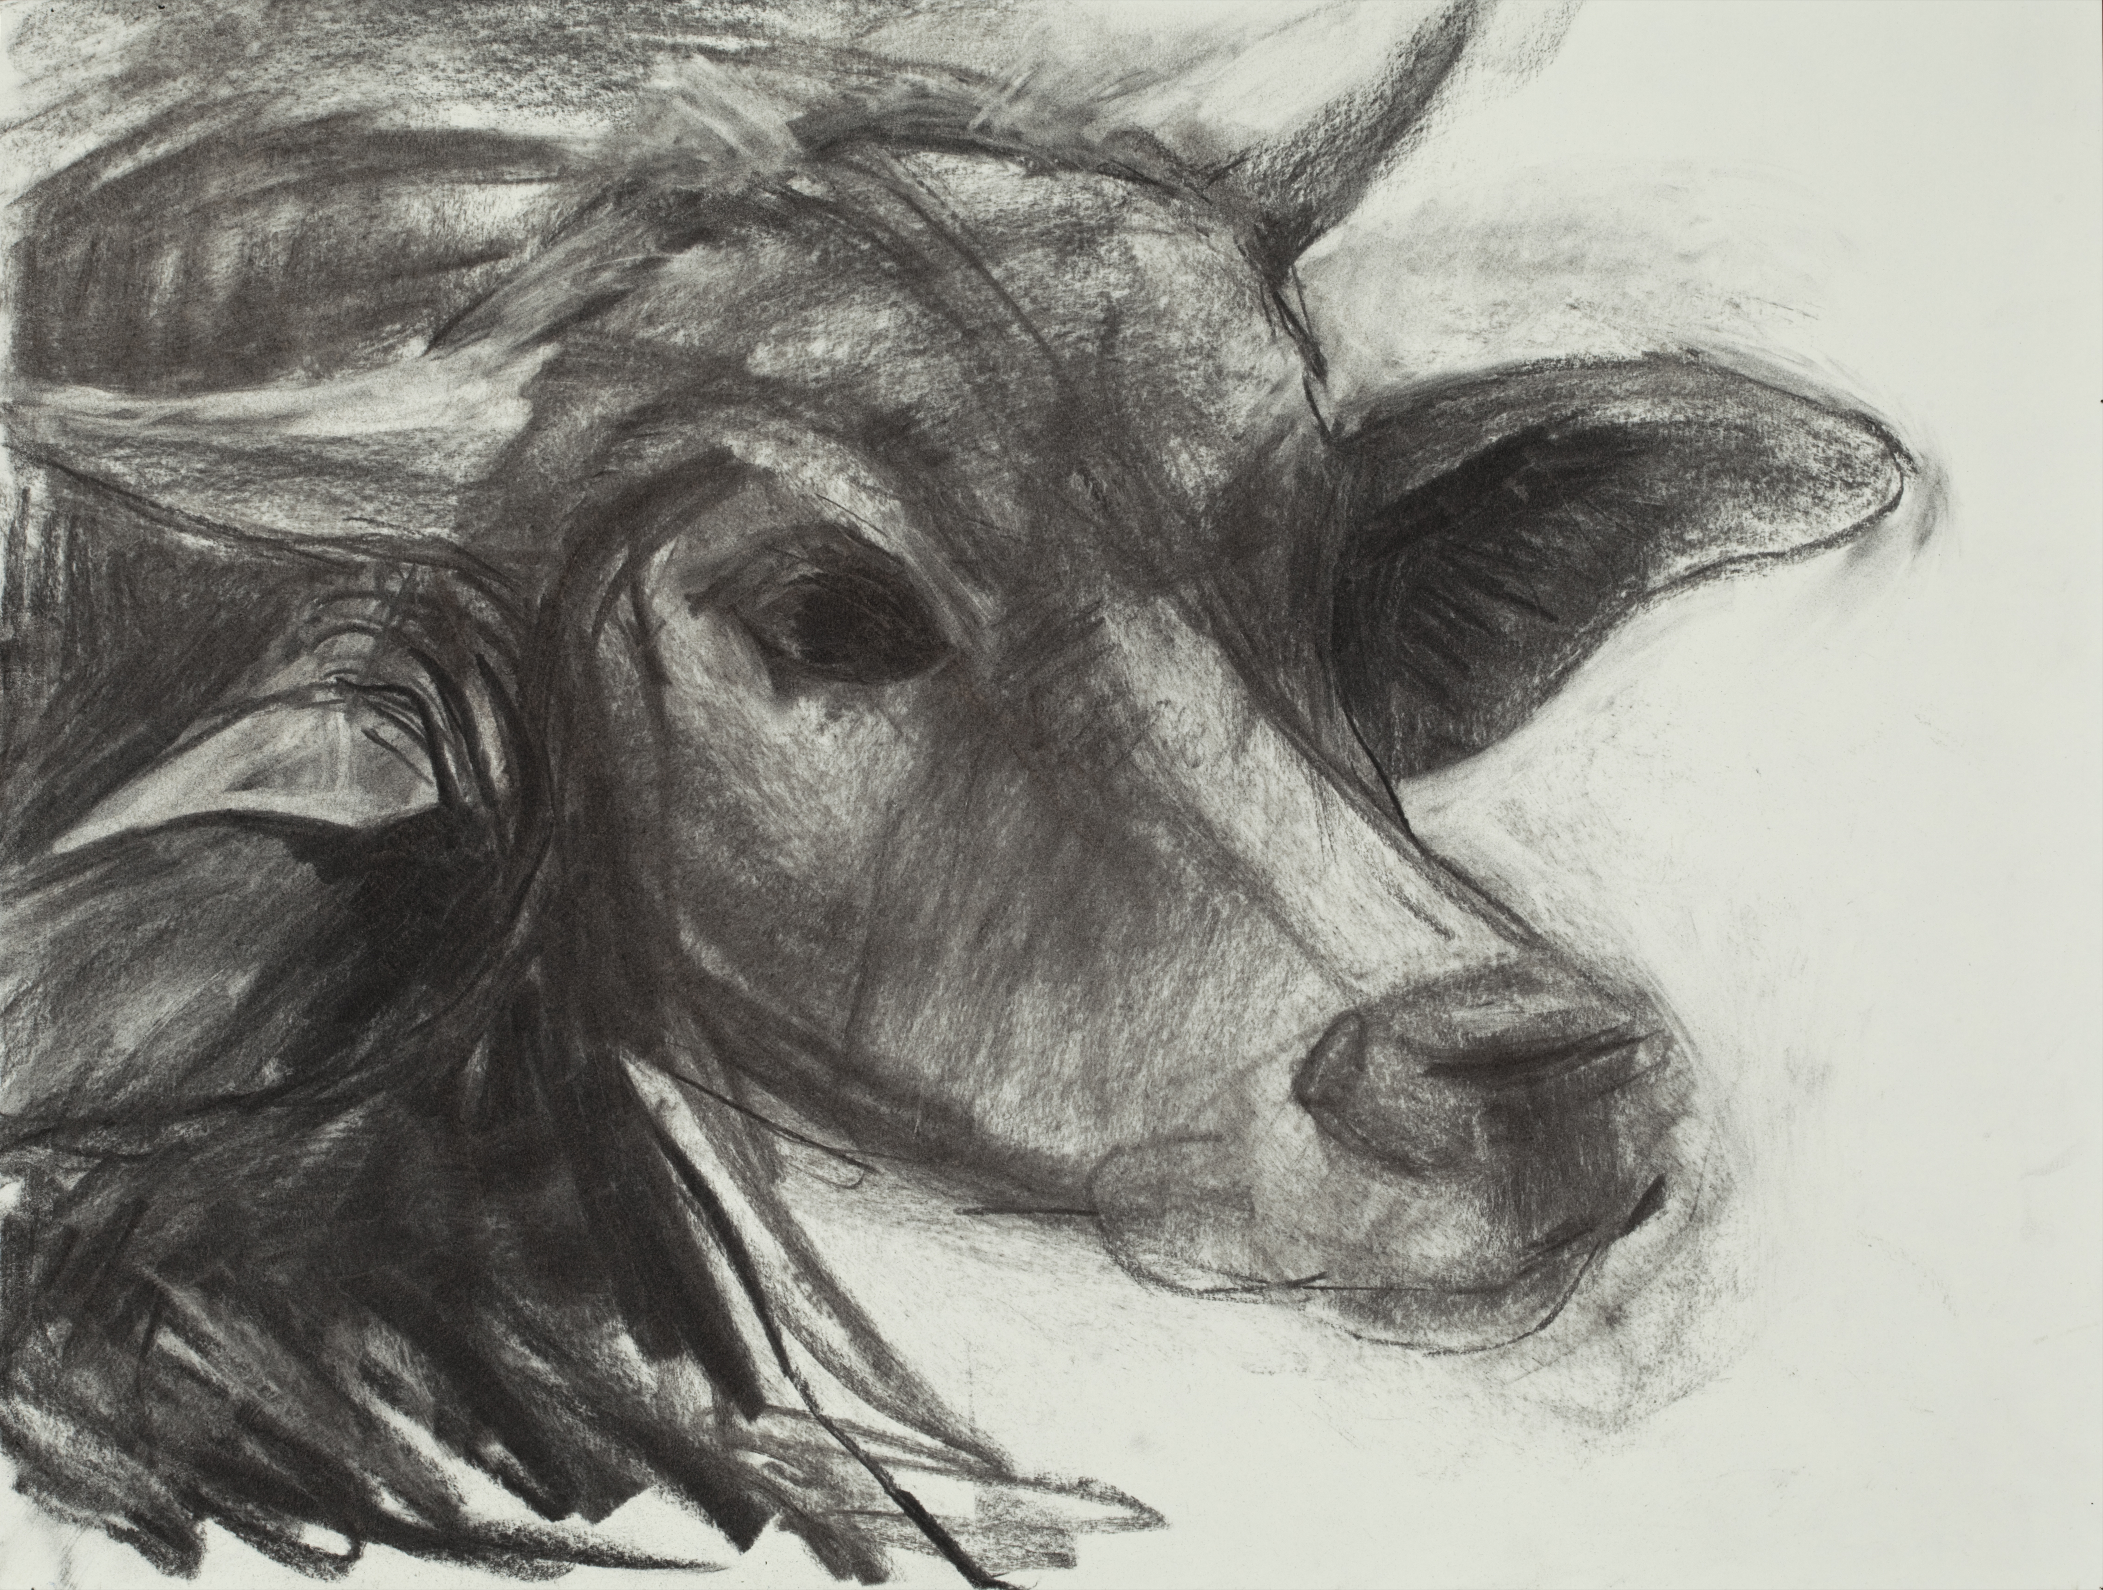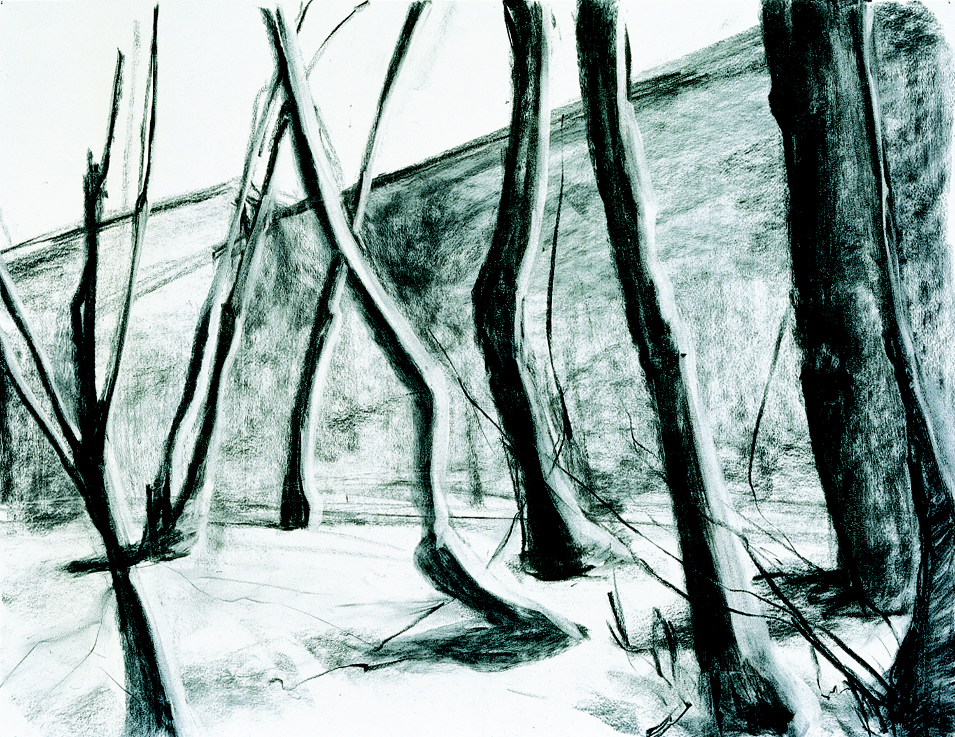

Send your check to:
Robynn Smith
Blue Mouse Studios
320 Day Valley Road
Aptos, CA 95003

831-685-4723 or email robynn@cruzio.com
www.robynnsmith.com

